**Report*:*** *CO2 Emissions in the United States (’90-’10)*

**Motivation:**

Climate change has become the focus of the public, policymakers and corporations since the turn of the millennium. The latest research has shown that climate change is positively correlated with levels of carbon dioxide (CO2). Notably, in recent years, significant policy changes have been made at both the state and national levels targeting different sectors’ CO2 emissions. Considering the U.S. population is distributed differently state by state and energy policies (for the most part) are determined at the state level, we want to examine how the different states have been emitting carbon dioxide over time. In California, for example, a bill was passed to commit to 100% clean (no fossil fuels) energy by 2045 in addition to providing tax incentives for driving “clean-air” vehicles. Additionally, the United States has since joined and exited the Paris Agreement – which was established within United Nations to deal with CO2 emission mitigation. Historically, given that there was very little contribution to reducing our impact on CO2 emissions, we want to understand the reasoning for why the United States has arrived at its current policies to combat climate change.

**Tasks:**

Provided a dataset on CO2 emissions within the United States from 1990 through 2010, we seek to understand the motivation for our current national and state policies on climate change. Specifically, we will leverage the data to aide us in answering the following questions: What has been the relationship between population growth and CO2 emissions on the national level? What about the state level? Is there evidence to suggest that states leveraged their emissions data when developing policy decisions? We plan to use a series of interactive visualizations to contextualize the problem and answer these questions.

Leveraging Tableau’s story feature, we constructed a series of dashboard visualizations with captions to create a sequential data analysis. We begin by comparing the national rates of population and CO2 emission growth, next we divide into the distribution of sectors, and lastly, we evaluate the same datasets on the state level. To conclude, we create an interactive plot that allows state policymakers to determine which sector they should address when attempting to reduce emissions.

**Visualization:** Here we have displayed the distribution of CO2 emissions on a national level over time:

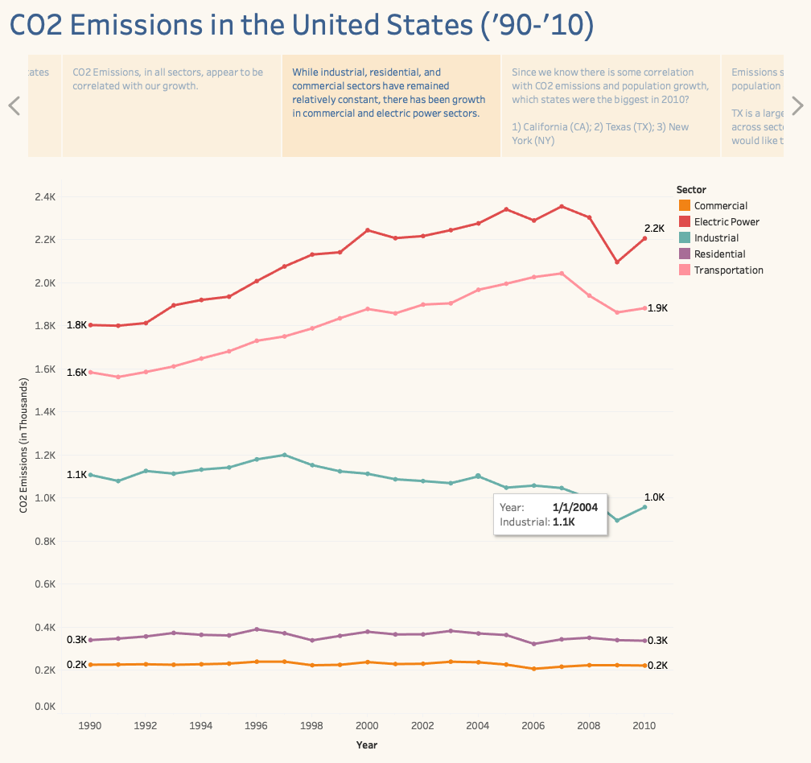

***Figure 1:*** *Distribution of CO2 emissions in the U.S. by sector, over time.*

Considering that CO2 emissions are measured on a common numeric scale (we believe the measurement techniques to be consistent across sectors), we consider this metric to be an ordered attribute. Additionally, as we are examining emissions over time on a scale of years, the years themselves also form an ordered attribute. By leveraging the *position* (both horizontal & vertical) channel on a common scale through plotting the emissions, we were able to convey the magnitude of the metric in both dimensions.

From there, the *length* and *angle* channels are able to capture trends associated with the emissions metric.

*Color* is then used as a channel to determine categorical difference between the sectors. Furthermore, when interacting with the plot by hovering the cursor, a tooltip is provided to call out the specific value at that position.

Through the use of these channels, Figure 1 is able to detail where the problematic sectors are on a national scale.

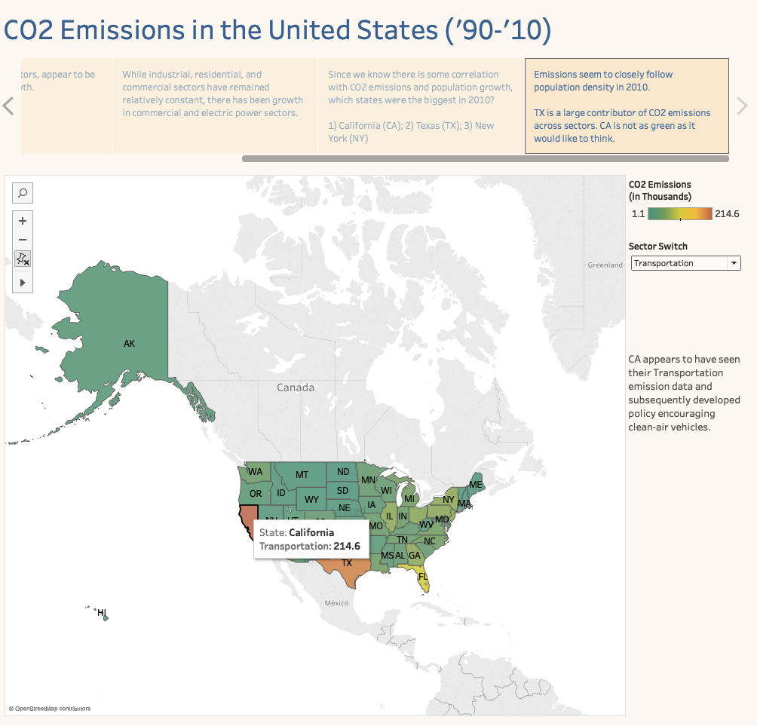

***Figure 2:*** *State distribution of sector emissions in 2010.*

Figure 2 plots the CO2 emissions by sector across the different states. The *position, length* and *area* channels (both vertical and horizontal) are leveraged to convey the differences between the states – in other words, a map has these channels built in already.

The *color* channel, specifically *luminance* and *saturation*, is then leveraged to display the previously defined metric of CO2 emissions – which are displayed on the scale of the sector. The sector switch allows the user to have control over which sector populates the color channel in the map.

**Assessment:** Given the set of questions identified, we believe our visualization adequately addresses them while following the channel effectiveness principles. The aim was to use a series of visualizations that allowed us to examine the relationship between population growth and CO2 emissions by sector in the United States.

Based on our graph sequence, we were able to determine that CO2 emissions are correlated with population growth, and that certain sectors appear to be growing faster than others. The final two visualizations suggest the impact of particular sectors in individual states and suggest for example why California may have developed policies related to clean transportation, as well as identify areas where states like Texas may need to focus policymaking effort.